Rittal TX Colo
Flexible, scalable and future-proof:
the new rack for colocation data centres
Herborn/Hannover, 2024-04-25.
The demand for computing power is significantly growing with increasing digitalisation and more and more AI applications in future – and thus the colocation market is booming. Businesses rely on high-performance IT infrastructures that are energy-efficient and secure, as well as flexible and scalable. The new Rittal TX Colo rack offers colocation providers the option of equipping their white spaces with ready-to-use, standardised solutions designed specifically for this market.
The global market for the colocation of data centres is set to grow by US$ 66.57 billion between 2024 and 2028. This is predicted in a report by the market research company Technavio. “The colocation market is continuously evolving at an impressive pace. This growth is driven by the growing demands on computing power, security, and scalability. Companies are increasingly looking for flexible and future-proof solutions with the increasing complexity and scope of IT infrastructures,” explains Anna Klaft, Vice President IT Business Unit at Rittal.

Advances in AI are also increasing the need for computing power exorbitantly. They are leading to more complex algorithms and models that require more computing resources. AI applications can vary seriously. “Colocation provides an efficient way of mapping the computing power increasingly required without the need for companies to run their own data centres,” explains Anna Klaft.

With colocation, companies rent either fully-equipped racks or an entire room from a specialist data centre operator in which to integrate their own IT equipment. They therefore do not have to operate their equipment on their own premises. Colocation providers offer state-of-the-art data centres that ensure the secure and efficient management of digital assets. However, the IT infrastructures have to perform at a high level: high energy efficiency, assured quality and reliability, global standardisation, documented evidence, and certification. At the same time, the components must be coordinated and rapidly scalable.

Rittal is helping colocation providers to quickly meet these requirements and the growing demand with its new TX Colo rack. “Our new rack enables vendors to perform at the highest level within the shortest time. They can equip their white spaces with ready-to-use, standardised, high-quality solutions,” continues the IT expert.
Immediately ready-to-use and combinable
The TX Colo was specifically developed for use in large data centres. Thanks to the use of standard components, the complete solution enjoys short delivery times, is pre-configured, and ready for immediate use. The pre-defined rack can be used without additional configuration and installation.
A standardised specification ensures consistency in the data centre, therefore the solution is compatible and can be bayed with other Rittal IT racks. It can be individually adapted, thanks to Rittal's extensive range of accessories and the practical 25 mm pitch pattern in the frame construction.
The TX Colo includes integrated air baffle plates and partitions to ensure optimum air flow. Roof cut-outs with brush strips across the entire depth and cable tray provide for simple cable routing. The VX comfort handle with numerical code lock offers additional access protection. The rack also features ventilated doors that support optimum climate control.
“The new rack is flexible with universal uses and will support the growing requirements in the colocation sector as needed. As a systems provider for IT infrastructures, we can also provide all other components. As the world's main supplier of racks, we are in an intensive dialogue with hyperscalers when it comes to developing the right modular cooling solutions for liquid cooling,” explains Anna Klaft.

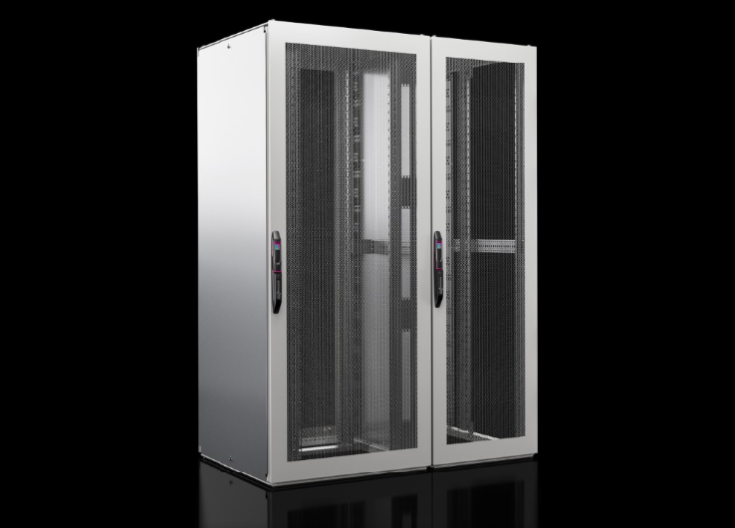  Caption  fri220402295.jpg: The new Rittal TX Colo rack offers colocation providers the option of fitting out their white spaces with ready-to-use, standardised solutions designed specifically for this market. |  | 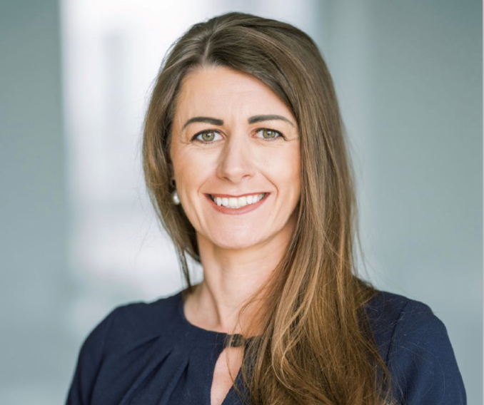  Caption  fri23214800.png: “Our new rack enables vendors to perform at the highest level within the shortest time. They can equip their white spaces with ready-to-use, standardised, high-quality solutions,” explains Anna Klaft, Vice President IT Business Unit at Rittal.

May be reproduced free of charge. Please name Rittal GmbH & Co. KG as source.

Rittal

Rittal is a leading global supplier of enclosure systems, automation and infrastructure with its industrial, IT, energy and power, cooling and service units. Rittal products and solutions are used in over 90% of global industries – standardised, customised, and always of the very best quality.
Our approach and methodology: Rittal, Rittal Software Systems (Eplan, Cideon and German Edge Cloud) and Rittal Automation Systems (RAS, Ehrt, Alfra) combine their hardware and software expertise to streamline, optimise and digitalise processes across the entire value chain for our customers including their IT infrastructure – from control and switchgear construction, machine building to factory operators or the energy sector.
Our delivery promise: Rittal standard products are delivered in Germany within 24 hours, and within 48 hours throughout Europe.
Customer focus
Improving efficiency and increasing productivity through automation and digitalisation is one of the biggest challenges for our customers. This requires in-depth knowledge and expertise, the combination of hardware and software, and cross-sector networking. We are convinced that creating and connecting data rooms is crucial to the success of industrial transformation. And that is exactly our speciality and field of competence.
Eplan and Rittal are driving the development of the digital automation twin, making data accessible and useable in operations as well. Cideon is improving data consistency in the digital product twin context with its CAD/CAM, PDM/PLM and product configuration expertise. German Edge Cloud’s ONCITE Digital Production System (DPS) makes production process data transparent, enabling it to be optimised – right through to energy management using digital production twins.
Sustainability
Environmental and climate protection, social commitment and ethical corporate management are a given for Rittal. We take our responsibility for a sustainable future seriously. Our approach to resource management and conservation involves continuous improvement of our own production processes and ensuring that our products have the lowest possible Product Carbon Footprint. Our solutions support our customers in achieving their own climate targets.
Family business and global player
Founded in 1961, Rittal is the largest company in the owner-operated Friedhelm Loh Group. The group operates worldwide, with more than 12 production sites and over 95 international subsidiaries. It has more than 12,100 employees and posted revenues of 3 billion euros in fiscal 2023. In 2023, the Friedhelm Loh Group was presented with the “Best Place to Learn” and “Employer of the Future” awards. In 2024, Rittal was awarded the Top 100 Seal as one of Germany’s most innovative medium-sized companies for the third time in a row.
For more information, visit www.rittal.com and www.friedhelm-loh-group.com.

Corporate Communications
Dr. Carola Hilbrand Rittal GmbH & Co. KG
Corporate & Brand Communications Auf dem Stützelberg
Tel.: 02772/505-2527 35745 Herborn
hilbrand.c@rittal.de www.rittal.com


Follow us:

